IDEAS FOR GLOBAL ELECTRIFICATION

M.Goia; N.Golovanov - NRC-WEC
Bucharest

According to the general opinion, energy consumption and particularly electricity is one of main indicators of evolution level of the modern societies. Its advantage consists in the versatility of its use to different purposes and domains, in the relative easiness to its obtaining from primary energy by numerous kind of turns and diversity of proceedings. The simple way of its transmission, distribution and transforming in different utilizations with good efficiency, offers a good level of hygiene and civilization to the society, and plays an increasing role in the socioeconomic development and the improving of standard living. And first of all, its relation with modern automatic and informatic systems is of enormous importance.
These aspects explain the increase of electrical energy weight from 9 to 20 % in global energy consumption worldwide during 1973 - 2010 Despite this fact, more than 20 % from world population (out of which 85% is located in rural areas) is deprived of the access to electricity, and over one billion people with access to electric current are deserved by unreliable power supply, having unplanned power outages, massive losses and worse power quality. Most of these people live in rural and remote areas, similarly those from yet not electrificated zones, their living standard being much below those of developed nations.
Typical examples are Sub-Saharian Africa where 70% of the overall population or South-Asia with some 50% of rural population (more 300 mil.people) lack access to electricity. [1]. Tab.1, shows the present access to electricity service according to [2]. and indicates that the population without access to its service is about 1440 mil. people (1230 in rural and 210 in urban areas). As far as the financial and technological solution in this matter will remain unchanged, in 2030 about 1210 mil.people will be have no electricity at all in 2030.
From this table results that the growth of population till 2030 is expected to result in cca. 1,5 billion. From this, thought urbanization, the urban population will increase and the rural will diminish. However [1] estimates the number of new connections clients) to be 580 million, to provide general electricity services for all, 60% in urban and 40% in rural.

Table 1. World's population without access to electricity
No | Zones | Total  (mill.) | % electrified | Urban  % | Rural  %
1 | Africa | 587 | 41,9 | 68,9 | 25,0
2 | Asia | 798 | 78,1 | 93,9 | 68,8
3 | Am Latin America | 31 | 93,4 | 98,8 | 74,0
4 | Middle Orient | 22 | 89,5 | 98,6 | 72,2
5 | Develop countries | 1438 | 73,0 | 90,7 | 60,2
6 | Traditional economies (+ OECD) | 3 | 99,8 | 100,0 | 99,5
7 | Total actual | 1441 | 78,9 | 93,6 | 65,1
8 | Estimated 2030  8318 | 4965 urban |  | 3353 rural
9 | Total 2009  6809 | 3397 urban |  | 3412 rural
10 | Total 2030  In actual technologies | 1213
11 | Total new connections | 4965 urban |  | 3353 rural

With a yearly average consumption /household of 1 MWh, the total electricity production necessary for this new clients, must achieve cca.580 TWh, representing only few upon 3% from global electricity production. In this situation, the endeavour to assure the universal access in 2030 to electricity, seems ambitious but achievable. The expected share of necessary connexions is presented in fig.1.[1].
Fig.1. World electrification until 2030. Nr.of news connections: 580 mil.
Urban 60%
Rural
12%
Rural izolat
6%
Rural micro gr.
19 %

The poor level of electrification at planetary level remains in the concern of important mondial leaders and organizations (UN, CIGRE, CIRED etc) they agreed to favourise and increase the access to modern, reliable and affordable energy services for all, and set the 2030 year as target for this scope, included in the planetary initiative of MDGs (Millenium Development Goals). They decided to involve all aid organizations, stiintifical networks, including Academic world to transfer the best practices and results for this special goal. In this sense is necessary to promote the cheapest classical and fancifull solutions, new technologies from renewable, use the best ideas (including smart grid) and more innovative financial policies and clean engineering’s!!
The great majority of World Governments are aware of the importance of a reliable infrastructure for developing the electrical energy supply. However, without a huge change in actual conception and policies, the isolated rural community will remain inherent deprivated of the facilities offered by electricity and have poor perspectives to exceed this serious handicap. The modern electricity is a prerequisite to support socio-economic development and improve of living conditions.

Romanian situation
Romania and other neighboring countries have the status of developing country. In the last 25 year, very few new zones were connected to the electricity, especially by extending distribution network in not electrified zones, after 1989. More people who have no access to electricity remain without access to the advantages to civilization. Very rare are the cases where independent micro grid was developed, from renewable solar energy.
The main cause of this phenomenon, similarly at world-wide are (into a personalisated order for both industrialisated or developing countries) the lack of financial resources, other priorities imposed by the political decision makers, the lack of imagination in the use of nonconventional technical cheap solutions bad directed subventions, and in our case, a legislative restriction concerning the efficiency of new investments in rural networks. Many other subjective explanations/reasons may be involved. All Romanian Governments since 1990 failed to solve or at least, ameliorate this hurdles.
Without adoption a new approach, to define a new real priority toward this target and without a real cooperation of all contributors, an entire state administration central and local, fundamental MDGs target will not obtained in Romania. The Romanian Distribution state owned Company, SC Electrica and other ONG organizations are concerned with this objective. Unfortunately the lack of interest of private distribution companies, all of these foreigner concerned on their own profit, and the reduced autonomy of Electrica, remove the perspective of general country electrification.
In Romania, like elsewhere on the earth, the consumers without electricity are placed in rural remote zones, with difficult access, having small perspective of density of electrical consume, far away from distribution networks. In June 2011 were 63547 rural householders un-electrified, from the 2087 localities from which 2360 householders from 95 localities total without electricity and 61187 householders from 1992 localities partly electrified.
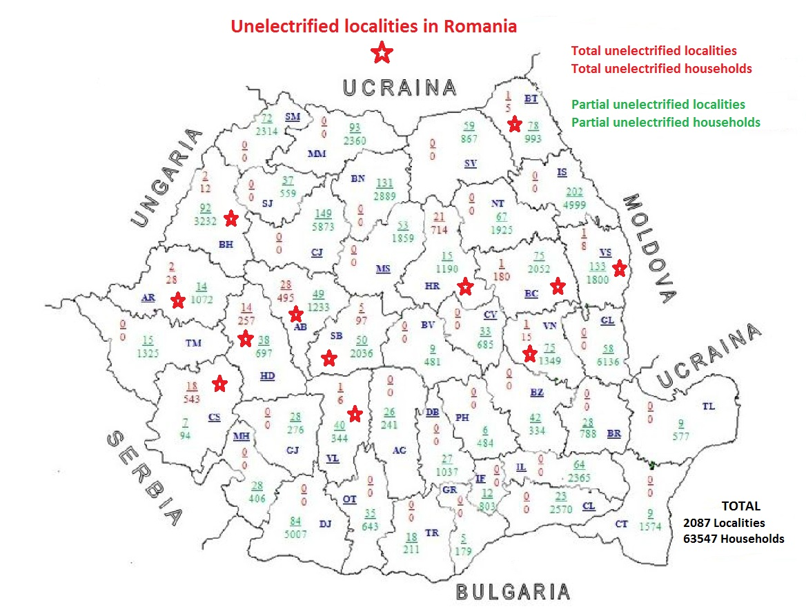
The consumers total un-electrified are only in the poorest zones from the districts in red colors from fig.2, named Alba, Arad, Bacau, Bihor, Botosani, Caras-Severin, Harghita, Hunedoara, Sibiu, Valcea, Vrancea, Vaslui.
Fig 2
All those consumers are to come prevalent from zones supplied by private capital distribution operators. This reality delays the final of global country’s electrification. Another impediment discouraging the investments in rural electrification is the stipulation which impose as the investment for network extension must be efficient and recoverable by new energy consumption. However, in poor zones it is difficult to obtain a reasonable period of damping. This stipulation remain in contradiction with the necessity to develop the poor and backward zones and blames numerous-still-Romanian people especially children from many communities on remaining back, be lacked in information and condemned to live in Middle Ages. This problem is not only the concern of some local administration but of entire society who has the duty to demonstrate opening and solidarity face them from poorest zones.
What are we the engineers going to do to solve this backward/fact? Upon the author’s opinion it is necessary a complex effort an approach of entire society containing new technical and much more diversificated off, micro, mini and classic grid solutions, to develop the use in practice renewable energy (photovoltaic & wind) ad put in operation some moral solidarity face our poorest citizens by forcing financial piercing.

Practical solutions
The costs of solutions based on electrical electric network vary by country, region and technical reglementation imposed by electric safety. Single wire, earth return (SWER) technology initiated in Australia seems be the cheapest. The solution was developed in South America and in Romania too in an experimental racord at 6 kV. The variant of general solution for SWER distribution is presented in fig.3.

CONNECTOR
CONNECTOR
Po
isolated cable
h>2,5m
h>2,5m
P
U>
I>
1
R
1
R
o
12
Ω
P
2
Low voltage
mast (isolated wire)
PT1
RACORD
PT2
PT SCHIT
7
2
5
6
13
4
1
8
3
8
10
9
12
8
11
12
R
2

Fig. 3. Diagrams for PT1 and PT2 at 20 (6) kV connection

1. Wood pole (H type or in concrete foundation), 2. Transformer 20/20 (6) kV 40 KVA- TMD,
3. Polycarbonate cabinet with current reducer, relays and d.c. battery,
4. Voltage transformer 20(6)/0,1 kV, 5. Single-phase connector 24 kV in vacuum, 6. Single- phase Ampact disconnector (ELCO), 7. OZn discharger (surge arrester), 8. OL- AL wire 50 mm² insulated,
9. Wood terminal pole (H type or in concrete foundation), 10. Fuse frame 24 kV+single- phase discharger SSFED (ELCO), 11. Single- phase transformer 20 (6)/0,231 kV 40 KVA- TMD,
12. Insulator 24 kV, 13. Insulator 24 kV, P1, P2 - Earthing 20Ω, R₀ - Earthing 12Ω
The substance of this solution consists in the assurance of protection against electric contacts by the parts permanent alive at continuous electric load (the groundings from source and to distribution – P1 and P2) and due the hazard appearing in the case of defect in the line when currents is much more dangerous than normal load. After mondial experience, confirmed in Romanian case, the SWER costs reach less 5000 $/km.
On the other part, in - SUA and Canada - experienced with much success the biphase technology presented in the next fig.5 and 6, much different than classic - European variant always based on triphase networks and transformers (fig.7). North-American solution cover different kind of users is based on mono-phased transformers, MV/0,23 kV, dry or oil immersed, self protected, having technical competitive performances, allowed to realize specific solutions to supplying small dispersated users, diminishing active power loses and maintaining a good level of energy quality. The solution costs 8000 $/km.
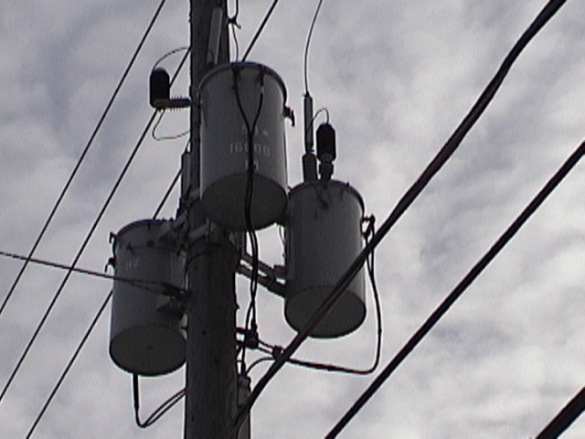
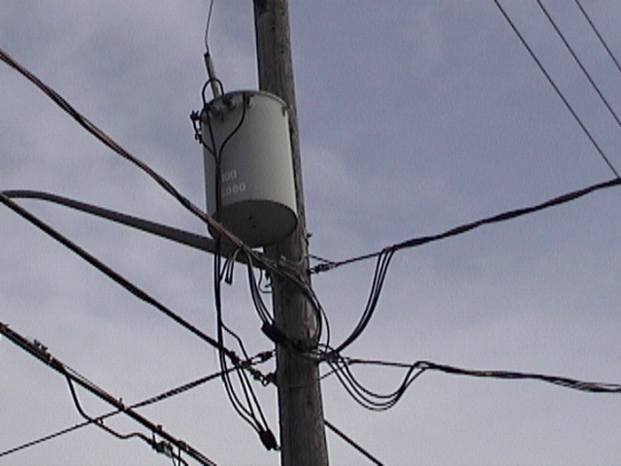
Fig.4. 3 monophase trans-
Formers MV/LV
r
Fig.5 Monophase transformer MV/LV

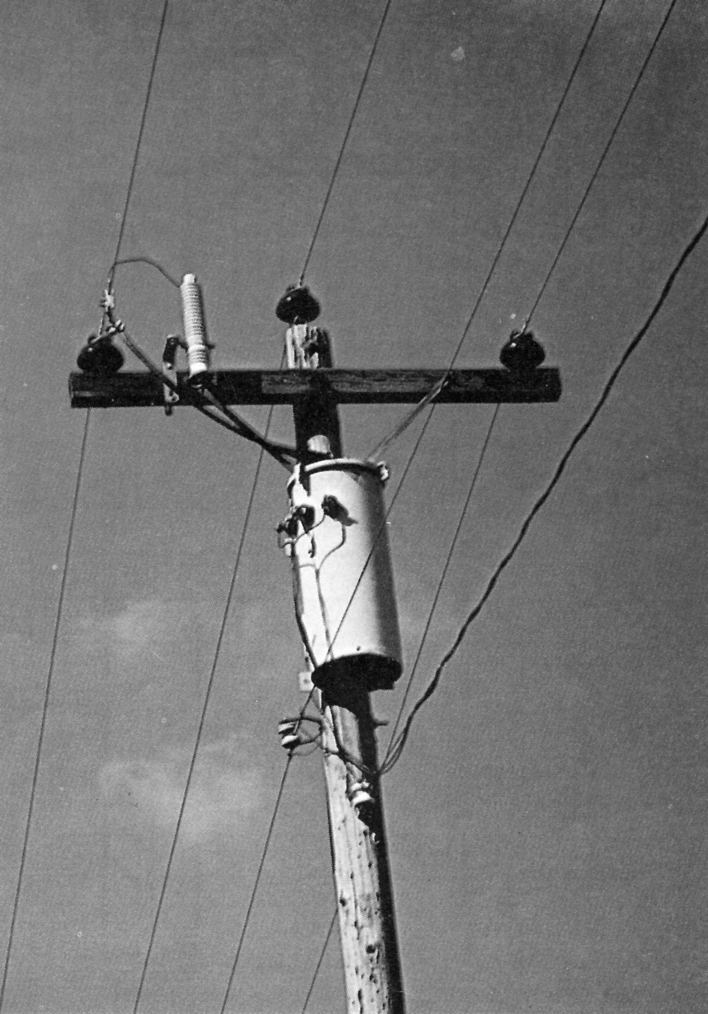
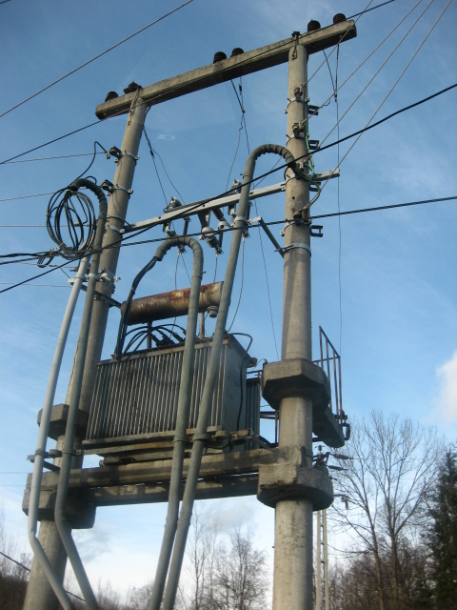
Fig. 6 Transformer post:
a) America de Nord; b) Europe (Romania)

It is for certain that, in global electrification will be implied in more and more cases mini or off grid solutions based on renewable energy sources originate from wind or more frequently by photovoltaic, especially in isolated communities interested only by lighting in residential buildings, schools or commercial use.
For larger communities with isolated grid extension and the perspective to increase the consumption for productive use may to adopt small micro-hydro or Diesel generating sets if delivered energy costs and continuity in supply may be reclaimed. This solution is warmly recommended in [1]. In the last fig. (fig.7) is shown the recommended schema.

Investment founds
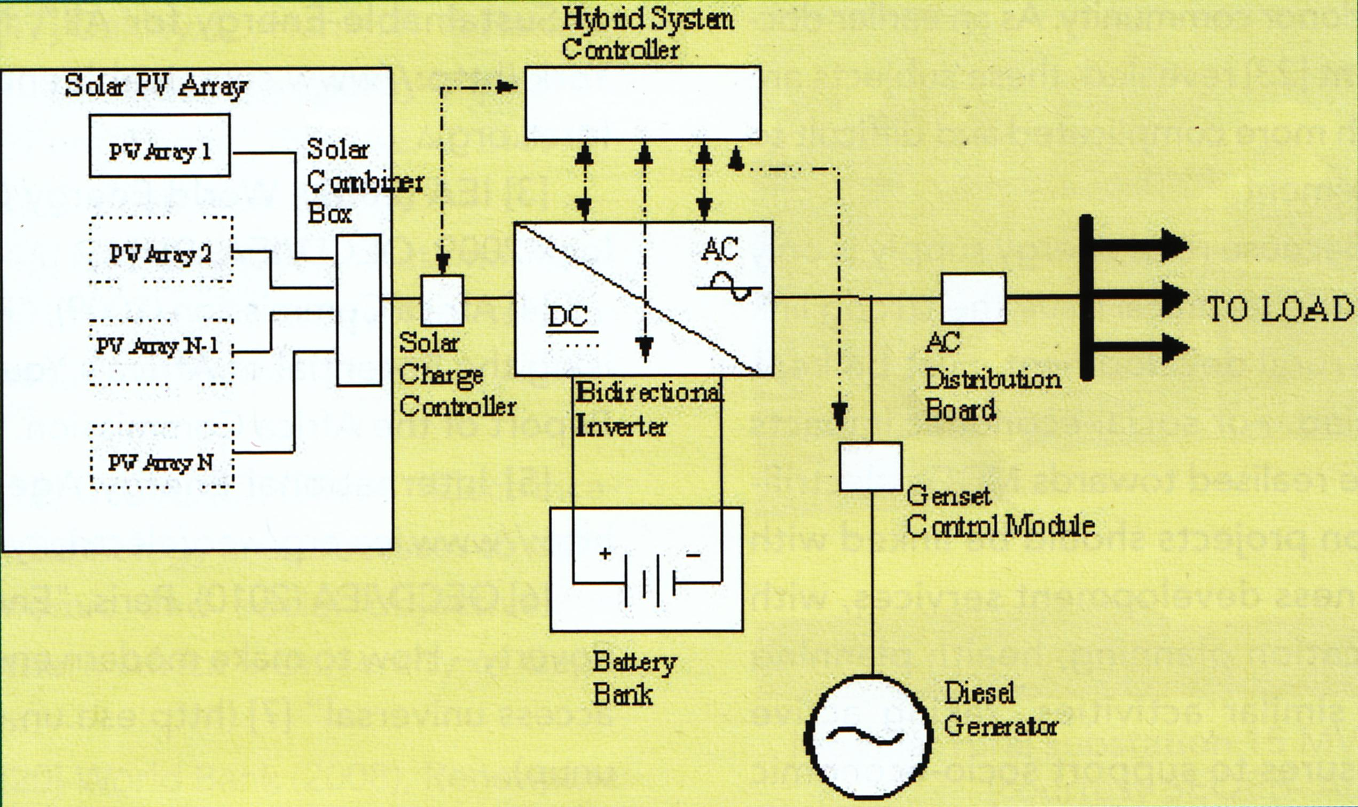
The total investments necessary at country level for global rural electrification from network classical solutions is of approximately 800 mil.lei equiv. 180 mil. Euro. Medium cost for a householder is 12,5 thou.lei. The repartition is unequal: 100 mil. for network connexion in the rural zones total un-electrified and 700 mil. for those partly un-electrified. The authors consider the proposed solution of this paper cheaper and helping the Romania’s general electrification.
Fig.7
Literature
[1]A.Zoomers & a. The global electrification challenge. In Electra, Dec.2011.nr.259.p.16
[2]N.Golovanov & a. Evaluarea problemelor energetice ale mediului rural In Mesagerul
Energetic sept.2012. pag41.
[3]M.Geanta & a. Evaluarea problemelor energetice ale mediului rural. In Conferinta
CNR-CME Aug.2012.

